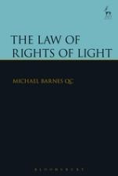
The Law of Rights of Light
Michael Barnes, QC

“Barnes gives us an important authoritative statement on the current law on rights of light [that] will be of great practical use to lawyers, advisers and planners as well as to landowners” Philip Taylor, Richmond Green Chambers

This book provides the authoritative statement on the current law on rights of light in England and Wales. The purpose of the book is to explain the law as clearly as possible. In practice rights of light issues and disputes involve technical subjects and inevitably answers to these questions require the expertise of technical experts such as light surveyors. An attempt is made in the book to explain from a non-technical point of view the way in which measurements and calculations are carried out in this area. It is therefore hoped that the book will be of use to lawyers as well as to landowners who may not always understand these technical subjects and to surveyors who may not always be familiar with the legal concepts and difficulties involved in the area of the law of rights of light.

Michael Barnes QC is a barrister and Queen's Counsel of Wilberforce Chambers in Lincoln's Inn and a Bencher of the Middle Temple.

April 2016 | 9781849468817 | 440pp | Hardback | RSP: £130
DISCOUNT PRICE: £104
Click here to order online – enter CV7 at the checkout to obtain your 20% discount

